Team TrV Runners for Hope
2024 Support Commitment

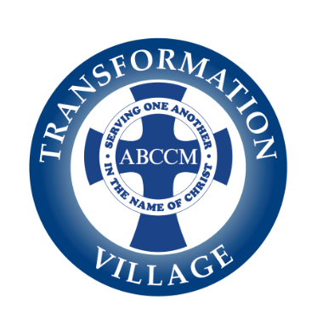

The Kiwanis Biltmore 15k/5k Classic Race is one of the premier races in WNC. The Kiwanis Club of Asheville is honored to have 30 runners sign up for Team TrV in their Run for Hope for homeless women and mothers with children.

What: Team TrV Runners for Hope participating in the Biltmore Kiwanis 15k/5kClassic Races
When: May 19, 2024
Where: The Biltmore Estate, Asheville, NC

The Team Transformation Village Runners for Hope’s participation in the Biltmore Kiwanis 15k/5k Classic Races benefits the women and children who live in transitional housing at our facility located at 30 Olin Haven Way. Your support provides a way for homeless women in our community to overcome obstacles and change the course of their lives.

Team TrV Supporter Benefits:

Title Sponsor – TBD

Gold Sponsor - Large color logo on team T-shirts
Logo on team webpage on ABCCM website
Company mention in all marketing efforts
Company mention at team reception

Silver Sponsor- Logo on team T-shirts
Logo on team webpage on ABCCM website
Company mention on social media
Company mention at team reception

Bronze Sponsor- Logo on race T-shirts
Logo on race webpage on ABCCM website

Hope Sponsor - Name on T-shirt
Name on ABCCM race website

Contact Name Title

Company Name I would like my company name and/or logo (call for information) to appear as:

_____________________________________________________________________________________________________
YOUR COMPANY LOGO: Please forward an electronic vector version of your company logo.

Address
City State ZIP
Day-Time Phone ( ) Fax ( ) EMAIL
Signature

- TEAM TRV - TITLE SPONSOR - $5,000
- TEAM TRV - GOLD SPONSOR - $2,500
- TEAM TRV - SILVER SPONSOR - $1,500
- TEAM TRV - BRONZE SPONSOR - $500
- TEAM TRV – HOPE SPONSOR - $250
- We are unable to provide a Sponsorship, but please accept our donation of $_______________
- WE WOULD LIKE TO SPONSOR AN INDIVIDUAL RUNNER-

RUNNER’S NAME _________________________________AMOUNT $__________________

Yes, we will support Team TrV Runners for Hope. Enclosed is my:

- Check made payable to Transformation Village
- Credit card information, as follows

Name Day-Time Phone ( )

Address (if different than above)

Credit Card # Exp Date ____ / ____ CVV ____________
Signature

- Yes, we would love to have a run team. Please send team leader information!

Please complete this form and mail to:
Transformation Village, attention Laura Foreman, 30 Olin Haven Way, Asheville, NC 28806 or email laura.foreman@abccm.org. For more information call Laura at 828-259-5300 ext. 2000

ABCCM is a 501(c)(3) nonprofit organization headquartered at 20 20th St. Asheville, NC 28806. Your contribution is tax-deductible to the extent allowed by law. TIN: 56-0945001

