ABCCM
October Eblast - HAV-VD
Deploys 10/17/23

Subject Line: WE OWE THEM OUR SERVICE: Honor a Veteran today!
URL Points: https://www.abccm.org/donations/honor-a-veteran/

Layout email as below. All assets have been provided. (Body copy on pg. 2)

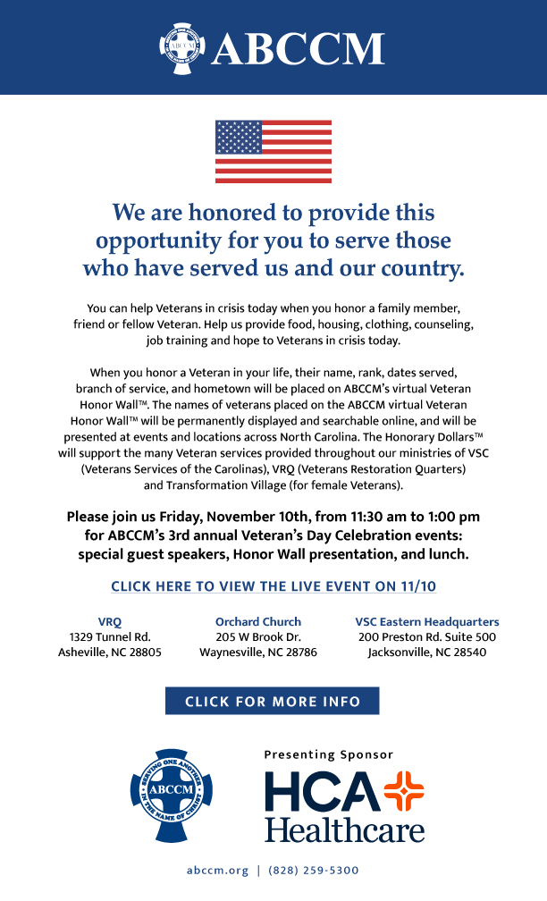
Body Copy:

We are honored to provide this
opportunity for you to serve those
who have served us and our country.

You can help Veterans in crisis today when you honor a family member, friend or fellow Veteran. Help us provide food, housing, clothing, counseling, job training and hope to Veterans in crisis today.
When you honor a Veteran in your life, their name, rank, dates served, branch of service, and hometown will be placed on ABCCM’s virtual Veteran Honor Wall™. The names of Veterans placed on the ABCCM virtual Veteran Honor Wall™ will be permanently displayed and searchable online, and will be presented at events and locations across North Carolina. The Honorary Dollars™ will support the many Veteran services provided throughout our ministries of VSC (Veterans Services of the Carolinas), VRQ (Veterans Restoration Quarters) and Transformation Village (for female Veterans).
Please join us Friday, November 10th, from 11:30 am to 1:00 pm for ABCCM’s 3rd annual Veteran’s Day Celebration events: special guest speakers, Honor Wall presentation, and lunch.
CLICK HERE TO VIEW THE LIVE EVENT ON 11/10
(Hyper link to https://www.abccm.org/donations/honor-a-veteran/)

Three column is possible:
VRQ
1329 Tunnel Rd.
Asheville, NC 28805

Orchard Church
205 W Brook Dr.
Waynesville, NC 28786

VSC Eastern Headquarters
200 Preston Rd., Suite 500
Jacksonville, NC 28540

